

OPERATIONS MANUAL
Rudy’s Flower Shop Ecommerce

“Let us Arrange a Smile for You”
😊



Dhruv Trivedi - 0802335
Abhishek Sharma - 0804379
Sacred Heart University
March 2018
OPERATIONS MANUAL

TABLE OF CONTENTS

1.0 General Information 1
1.1 System Overview 1
1.2 Project References 2
1.3 Authorized User Permissions 2
1.4 Points of Contact 2
2.0 System Operations Overview 2-1
2.1 System Operations 2-1
2.2 Technical Information 2-1
2.3 Resource Inventory 2-2
2.4 Processing and Communication Overview 2-3
3.0 Project Development Timeline (Problems and Solutions) 3-1
4.0 application process 4-1
5.0 future enhancements 5-1
6.0 citations 6-1

1.0 GENERAL INFORMATION

GENERAL INFORMATION

1.1 System Overview

Rudy’s flower’s shop doing this business from more than 50 years. In now day’s digitization in every business’s must. So, we’re developing an e-commerce portal for Rudy’s flower shop. The Project shall include:

- Online selling of flowers bouquets cookies and other merchandise.
- It is a Client Server Web based application which’s divided into two parts:
- Client Side
- Admin Panel
- Users(clients) can access Client side over the cloud.
- Admin-side can be accessed for updating and managing the Inventory and Orders
- As we’re final year student of a great University SACRED HEART UNIVERSITY, FAIRFIELD CT. we got this opportunity to develop this system.
- System name is: Rudy’s flower shop. “Let us arrange a smile for you. 😊”
- System platform is .NET, Azure Cloud.
- System category & Security:
- It’s an ecommerce categorical website with MD5 security well maintained session and cookies.
- It’s an ADP system with self-backup and recovery system for data. As a backend we used Microsoft SQL Server.
- Operational status:
- Operational (beta version)
- Under development (update can be done please refer future enhancement section on page number 27)
- This system is platform independent. That can work on (Windows, Linux, macOS).

1.2 Project References

Provide a list of the references that were used in preparation of this document in order of importance to the operations staff. Please refer citations.

1.3 Authorized User Permission

This system provides a protected environment for data security and admin cannot login without proper authorization.

1.4 Points of Contact

1.4.1 Information

Point of contact:

Client side:
Name: Dhruv Trivedi
Client-side developer and database and security architect and deployment technician.
Contact email: trivedid17@mail.sacredheart.edu

Admin Panel:
Name: Abhishek Sharma
Admin-side developer and designer.
Contact email: sharmaa3@mail.sacredheart.edu

Undertaking of:
Name: Dr. Tolga Kaya Ph.D.
Associate Professor
Contact email: kayat@mail.sacredheart.edu

2.0 SYSTEM OPERATIONS OVERVIEW

SYSTEM OPERATIONS OVERVIEW

2.1 System Operations
The system is divided in to three parts as:
- Client-side
- Admin panel
- Service API

Client-side:
Please refer Client developer’s manual for this.

Admin Panel:
- Admin-side allows user to see all the inventory of Rudy’s flower shop.
- Admin can add new inventory.
- Admin can make changes in existing inventory.
- Admin can delete existing inventory.
- Admin can view orders placed by customers online.
- Admin can change the status of the orders.
- Admin can view all the users existing in the database.
- Admin can update the details of the users.

Service API:
- API provides a bridge between database and application.
- Provides all the handling for request and response.
- Provides all the securities.
- Encrypts all the communication.
- Provides SQL Injection free environment.
- Reflect all the changes from client to admin (vice versa)..

2.2 Technical Information

Entire system is developed in three different workspaces as,
- Client side
- Admin panel
- Service API

Client-side:
Code Behind: Client-side is developed in .NET framework using c# programming language.
Frontend: HTML5, CSS, JavaScript, jQuery, AJAX
Backend: All manipulation and request response call will be made and catch by Webservice API (REST)

Admin Panel:
Code Behind: Admin Panel is developed in .NET framework using c# programming language.
Frontend: HTML5, CSS, JavaScript.
Backend: All manipulation and request response call will be made and catch by Webservice API (REST)

Service API:
Code Behind: Service API is developed in .NET framework using c# programming language.
Backend: Microsoft SQL Server 2017.
Deploy: Microsoft IIS 8.0 (localhost).
(To see deployment please refer deployment manual for that.)

2.3 Resource Inventory
To develop this project these tools are used,
- Microsoft Visual Studio 2017
- Microsoft SQL Server 2017
- Cristal Report
- Microsoft Visual Code
- Adobe Photoshop
- Microsoft Office.
- Microsoft Windows Movie Maker (to make tutorials)
- Microsoft Visio.
- IIS server 8.0.
- GIT

Other resources that we learned but not useful for our project with reason:

- Telerik UI
- OpenCV
- Adobe photoshop SDK for .NET
- Doctor Design API
- SQL Server Reporting Services
- Report Builder 3.0
- HTML2CANVAS API
- Slingshot API
- REST builder
- MATLAB

2.4 Processing & Communication Overview

Diagram

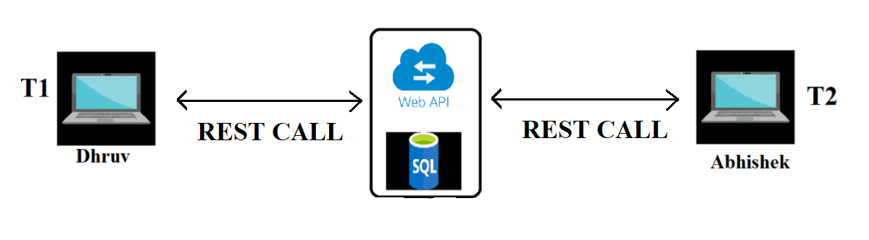

3.0 PROJECT DEVELOPMENT TIMELINE
PROBLEMS AND SOLUTIONS

TIMELINE
In this section, details about how I developed this client-side portal, what challenges I faced what I learned, and how I tackled that.

3.1 Week one:

Description:
In the first week Dr. kaya assign us the real-time project of Flower shop. After that we’ve done some R&D about this thing as below:
Requirement gathering:
- First, we studied old system what they are using now.
- Supply chain of the business.
- What they are lacking in terms of IT field.
- As per the new generation development what should be there.
Through all this information we’ve made a layout for the project.
So here is the layout of our project:
- This web portal will be divided into two sides one is customer portal i.e. Client side, and one is Admin side.
- We’re going to use .NET Framework, angular, JSON, JS, CSS and HTML5, OpenCV (framework for image processing) later it with switched with AJAX.
- Next steps to create database dictionary for the project.

Challenges:
There are so many online shopping carts for flower shop. We want to add something unique in our portal. We discussed this and came with many suggestions.

- Magento portal
- Create your own product
- BOT that sense what kind of flowers will customer going to like.
Etc.

Solution:
We’ve discussed all this concepts with Dr. Kaya. And as conclusion we have decided to go with create your own product engine.

In this engine user can select flowers from inventory and create own product according their choice and mood. Even user can add cookies or gift items in the order.
Engine is totally dynamic and user driven.

3.2 Week Two:

Description:
We decided and designed our work and timeline and set our milestones accordingly.
I am going to work on Admin Portal and Dhruv’s going to work on client-side.
We started with design database together so that we both can synchronize our area of understanding of this project flow. We have developed a basic structure of database dictionary.

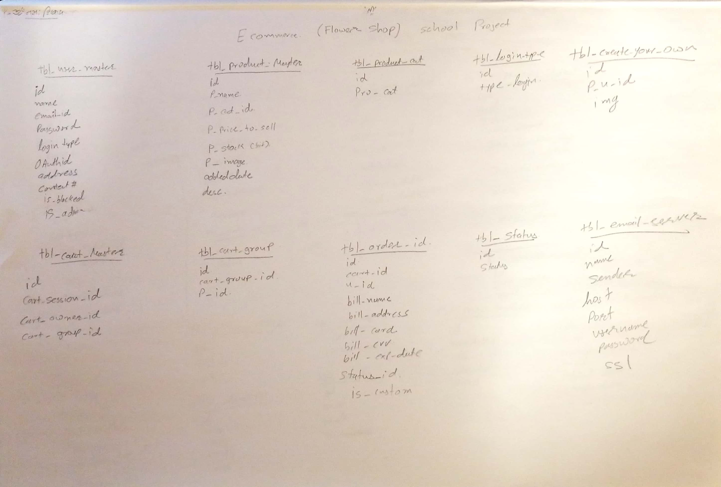

3.3 Week Three:

Description:
I have started designing the pages of the Admin Side. For which I am using HTML5, CSS and JavaScript.

3.4 Week Four:

Description:
I have been working on the Login page.

3.5 Week Five:

Description:
I completed the Login portion and now working on adding new inventory with the image of it.

Challenge:
I was able to save the data but not the photo with it.

3.6 Week Six:

Description:
I started working on the retrieving the list of all the inventory.
Also worked on saving the image of the inventory.

Challenge:
I am struggling with the retrieval of image from the inventory

Solution:
I got to learn how to use FileStream and BinaryReader to save and retrieve image from database.

3.7 Week Seven:

Description:
Started working on editing the details of inventory.

3.8 Week Eight:

Description:
Started working on user’s list and how to edit the details of the users.

3.9 Week Nine:

Description:
As per the hosted webservice, we were able to link both, client side and admin side of the project.
Started working on the receiving of orders from the client side.

Challenge:
Linking with the other computer with the webservice.

3.10 Week Ten:

Description:
Worked on changing the status of the order received and reflecting it on the client side as well.

3.11 Week Eleven:

Description:
Finalizing all the validation and testcases for application added email notification to client and server.

3.12 Week Twelve:

Description:

Making User manual tutorials for easy use.
Making of the Developer’s Manual.

Application process

Application flow

4.1 Login Page
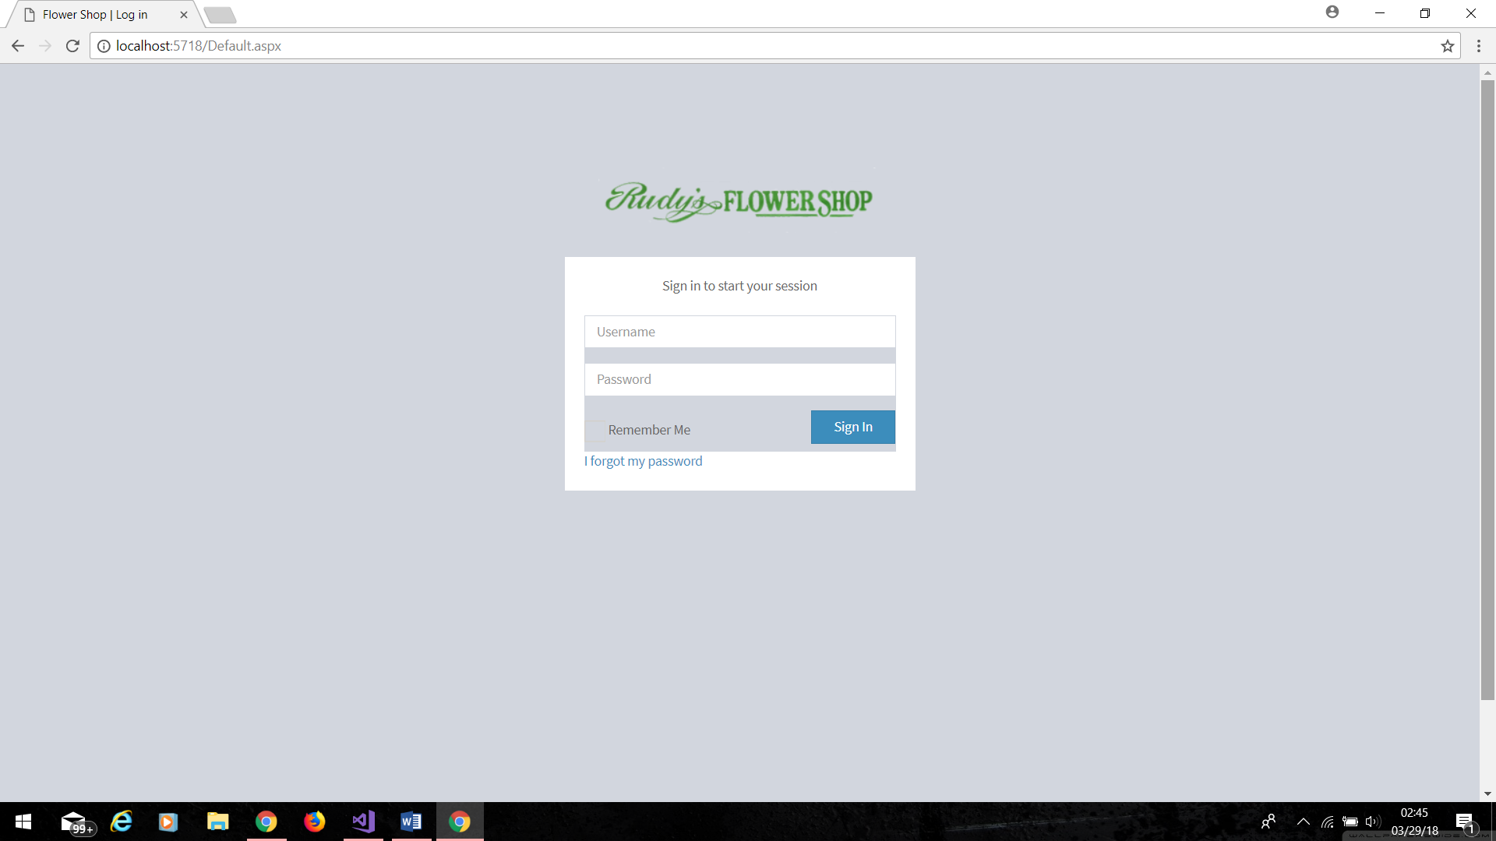

4.2 Home Page
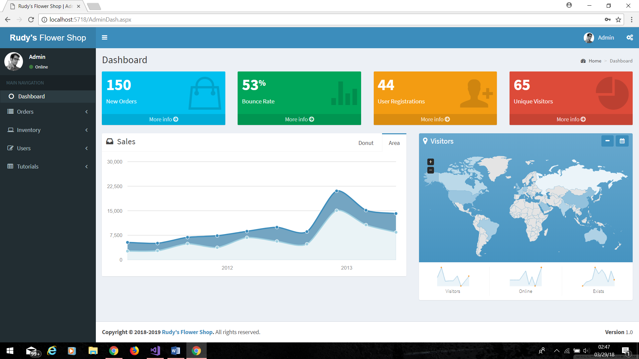

4.3 Order List
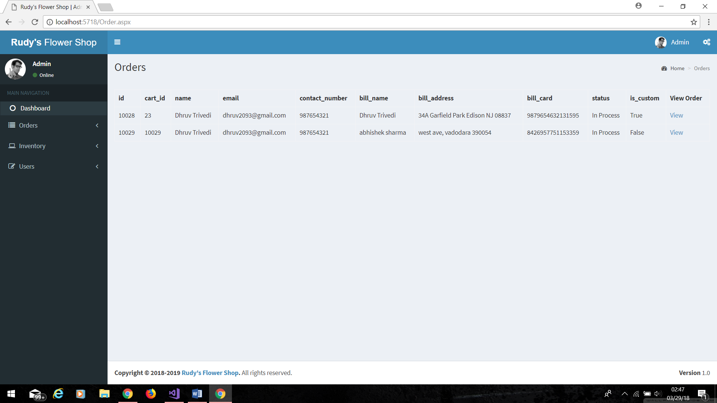

4.4 Update Order Status
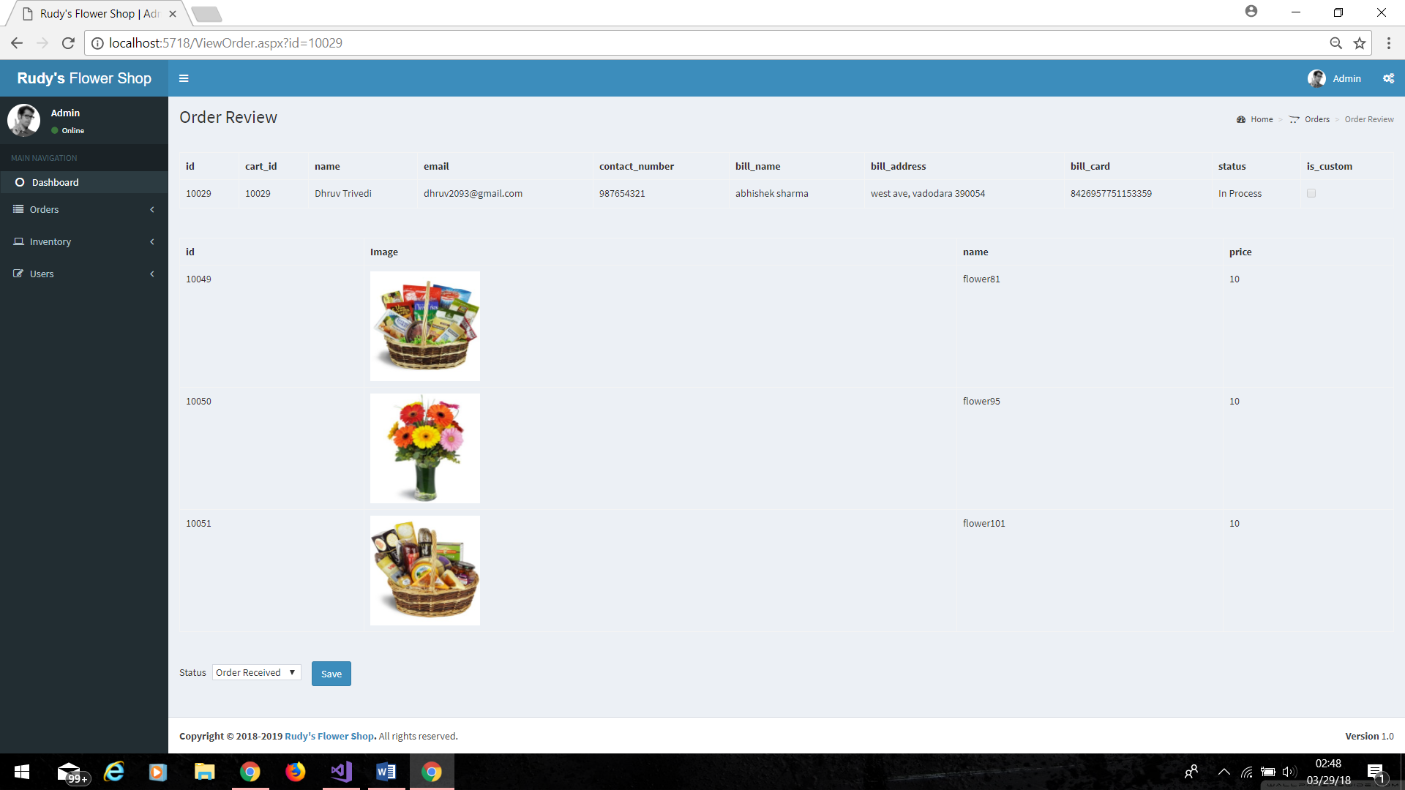

4.5 Add New Inventory
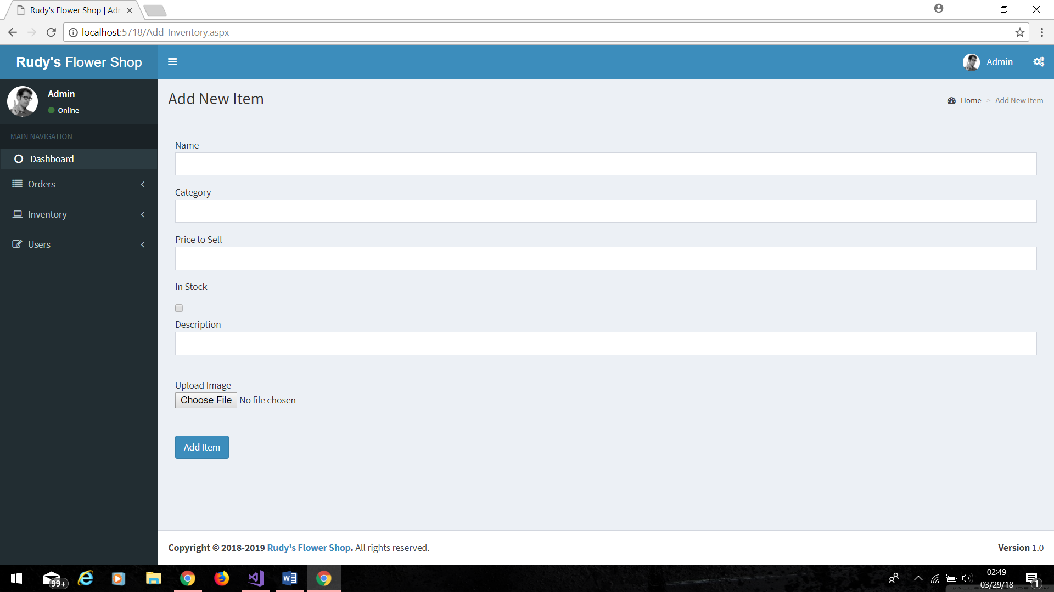

4.6 Inventory List
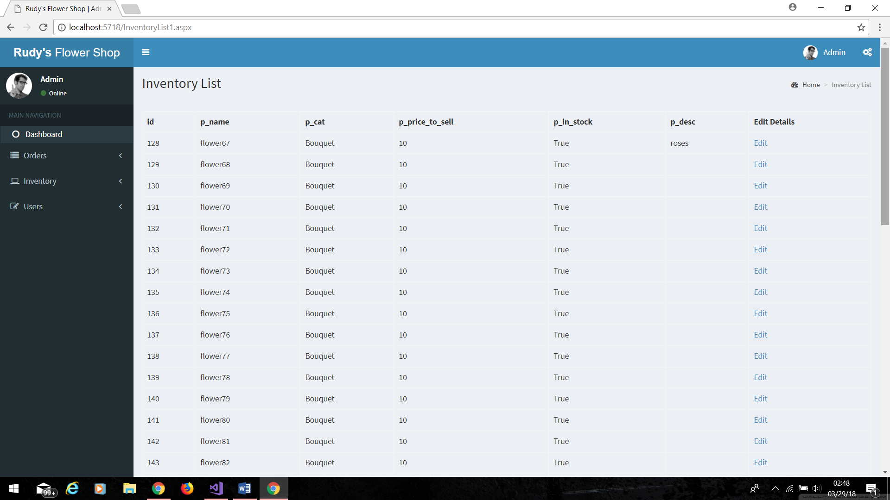

4.7 Update Inventory Details
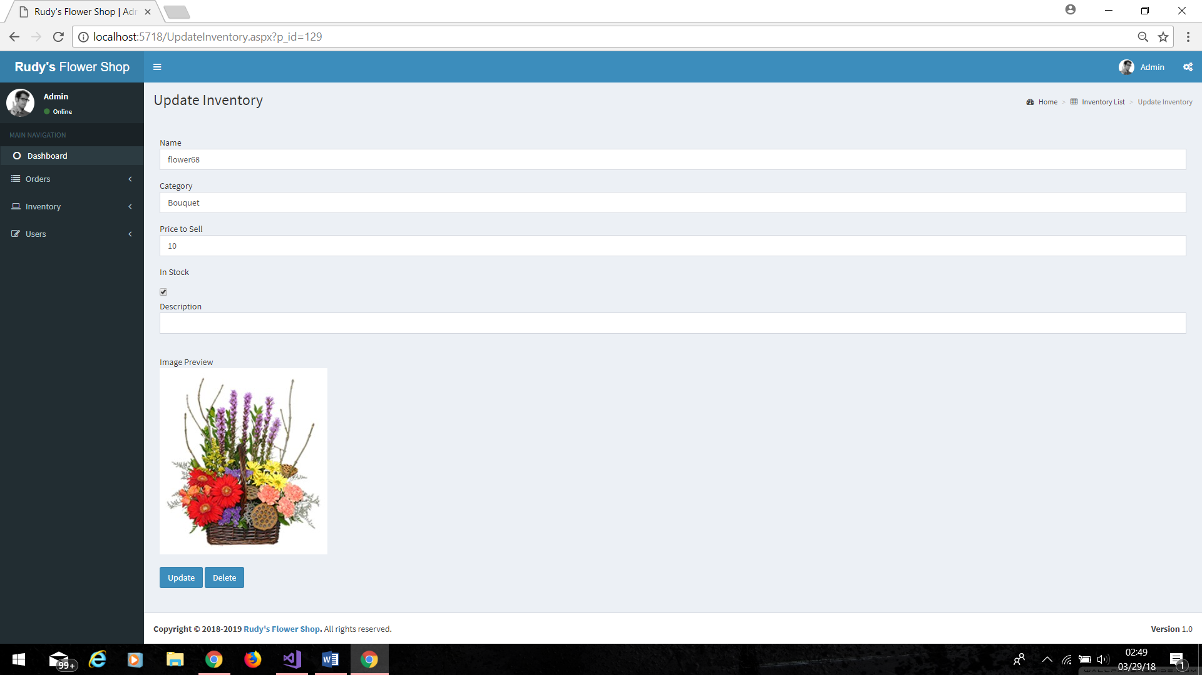

4.8 User List
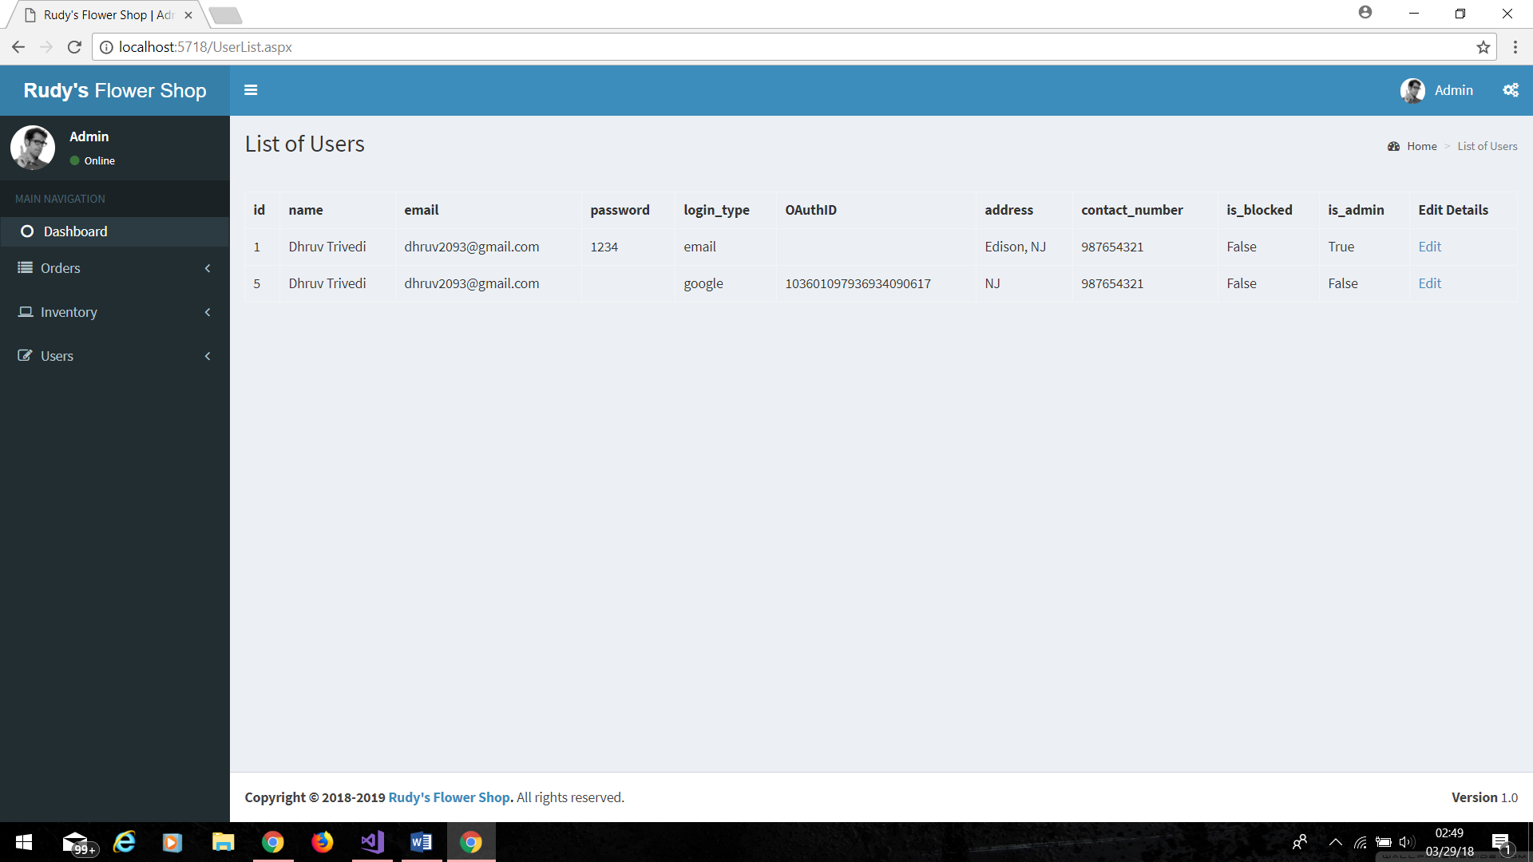

4.9 Edit User Details
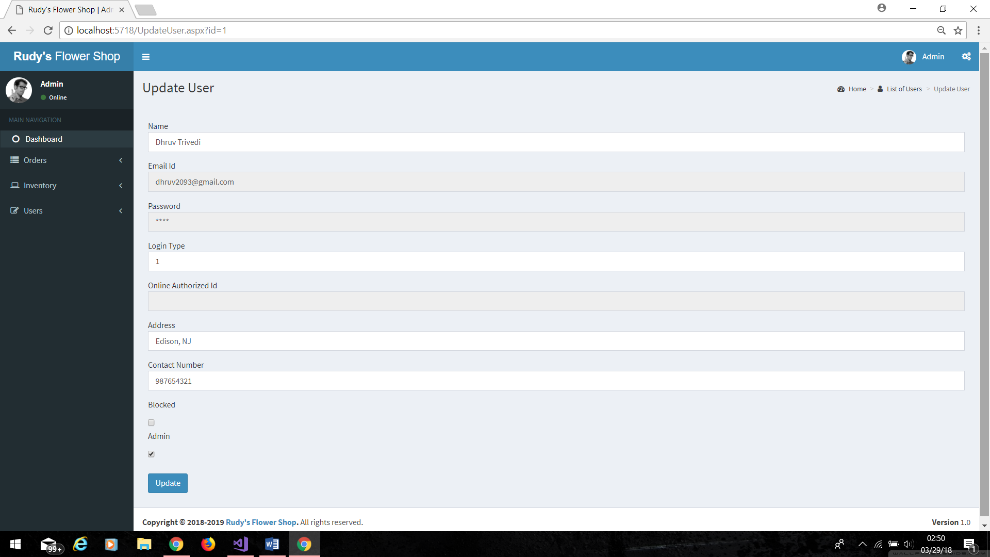

future enhancement

- We can implement notifications panel
- We can add a whole new section for promotional offers
- We can add category in the inventory
- All kind of filtrations

citations

Major citations:

- https://www.c-sharpcorner.com/
- https://www.aspsnippets.com/
- https://www.iis.net/
- https://docs.microsoft.com/en-us/aspnet/web-api/overview/advanced/calling-a-web-api-from-a-net-client
- https://support.netdocuments.com/hc/en-us/articles/205219850-API-Documentation

